Using MLGW as ML-logger

MLGW from SW 1.61a can be used as ML-logger if it’s needed to monitor communication on ML.

The unit with serial: __ __ __ __ __ __ __ __ is ready for logging so you can skip step 3 to 11

If you don’t want to read out data you can skip step 3 to 12 and just return the box with logged data when an error have occurred (no recommended)

- Connect MLGW to ML system.
Use spare connection or add Master Link Distributor Box.
- If MLGW is already prepared for logging you can just turn on power and skip step 3 to 11
Green front panel LED starts continuously blinking after 1 min. if logging is already active.
When LED goes from red to (blinking) green, the MLGW sends an All Standby to both Audio- and Video Master. This can be used to check that ML connection is OK.
- Connect MLGW through router or direct to PC (maybe crossed Ethernet cable is then needed)
- Set up router and PC to subnet 192.168.1.xxx
(MLGW can also be changed to other subnet or DHCP, ref. MLGW Installation Guide on BeoWise).
- Open browser and select:
http://192.168.1.10/gui/SystemTimePage
(replace ‘192.168.1.10’ if default address is changed or use ‘mlgw.local’ if possible). 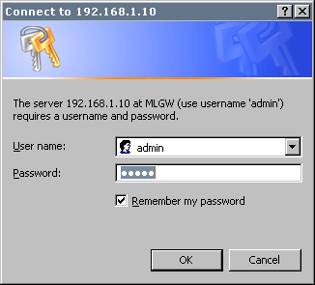
- Login using default password: admin
- Select System, Date&Time, Synchronize with BeoLink products
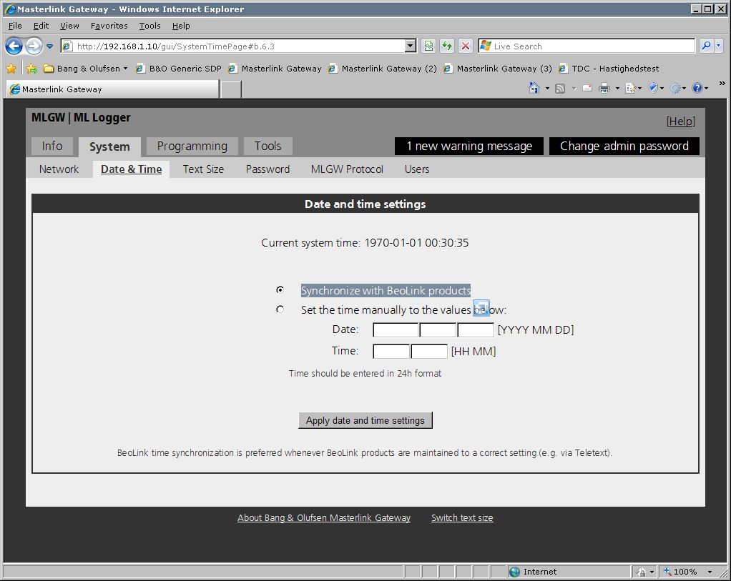
- If ML system doesn’t contain HW clock then set time manually
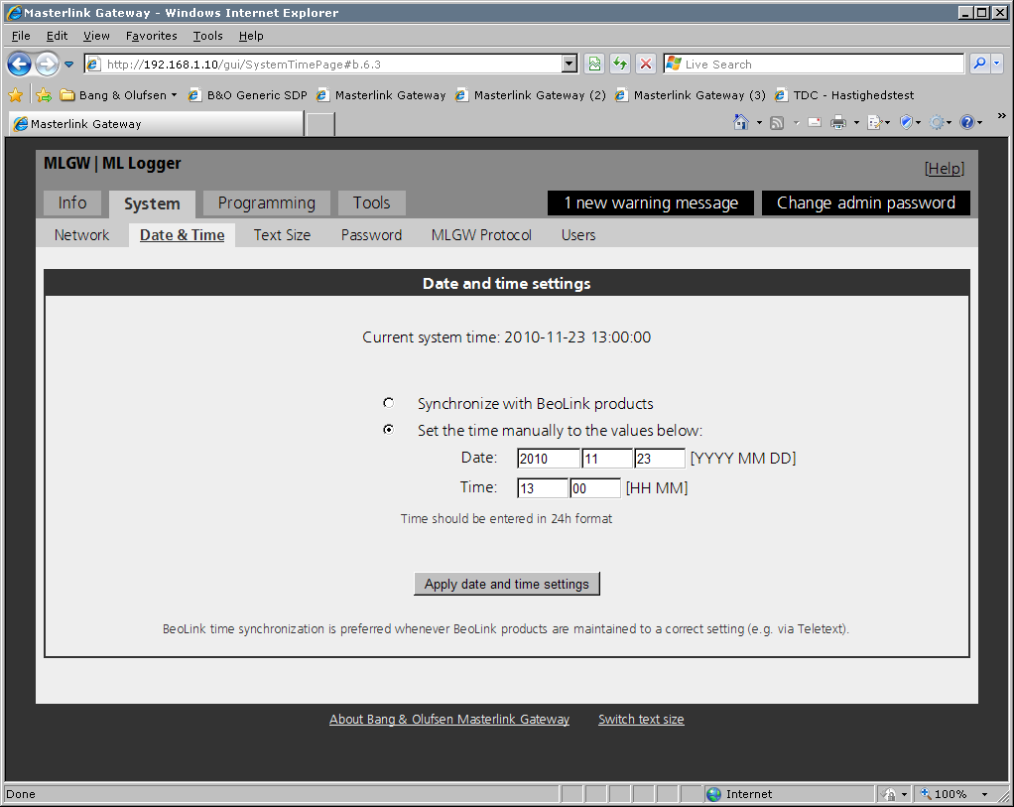
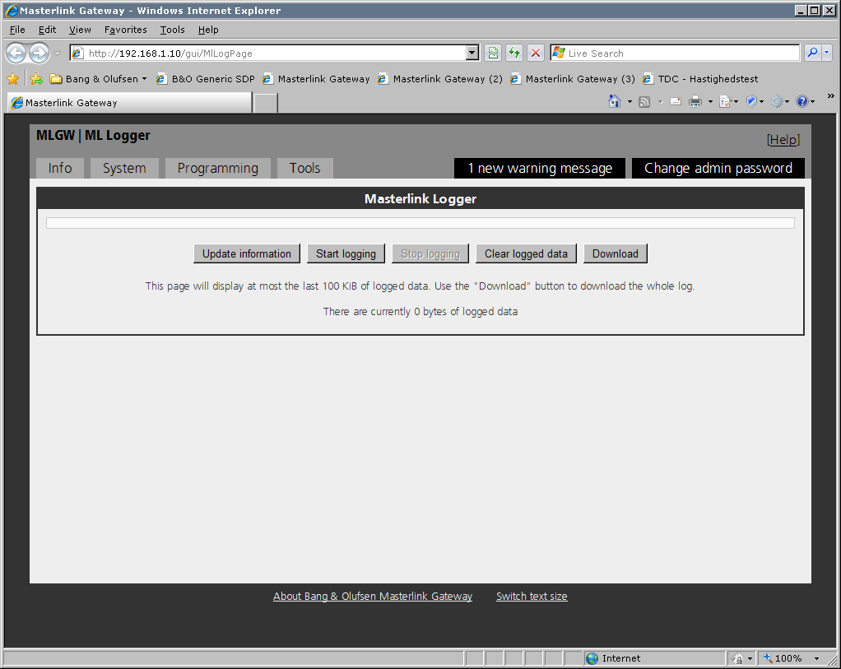
- Select http://192.168.1.10/gui/MlLogPage
- Select ‘Start logging’ if not already started (grayed out).
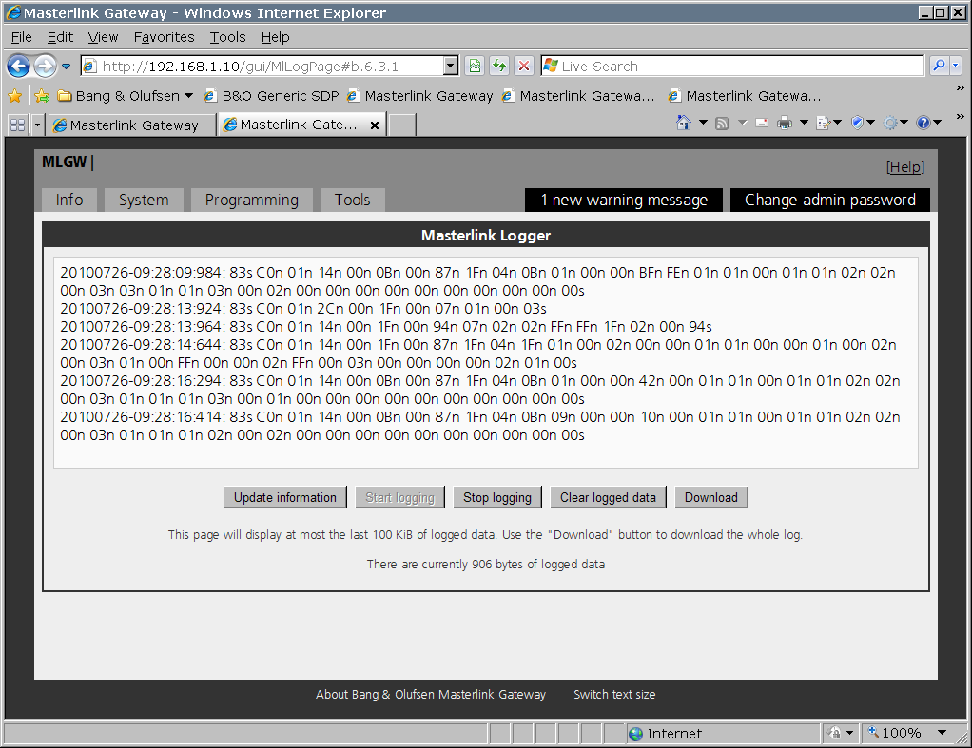
- If logging is already started the some HEX values should show up.
Select ‘Update information’ to see the latest values.
Green front panel LED is continuously blinking if logging is active

- When error situation has occurred then Open browser and select:
http://192.168.1.10/gui/MlLogPage
Select ‘Download’ to save the file.
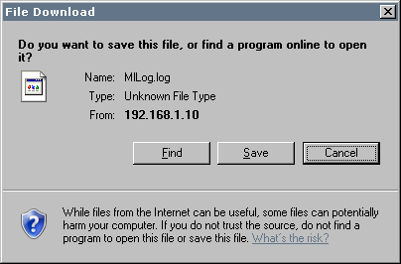
Use filename like ‘T_Jensen_2010-07-26.log’
Please also note time of error.
- Select ‘Clear logged data’
- Send file (or MLGW), error description and time of error to B&O

