Access Customer Service Menu by:
Press the MENU button on Beo4 to get into the "Set-up Menu".
Place the cursor on ´OPTIONS´. Press the RED button and within 3 seconds press GO.
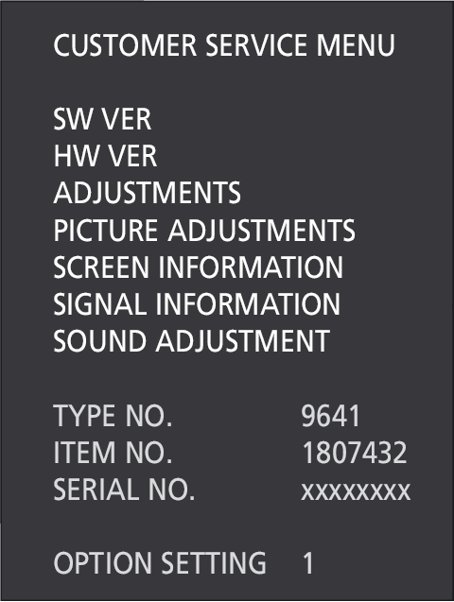

Select ADJUSTMENTS
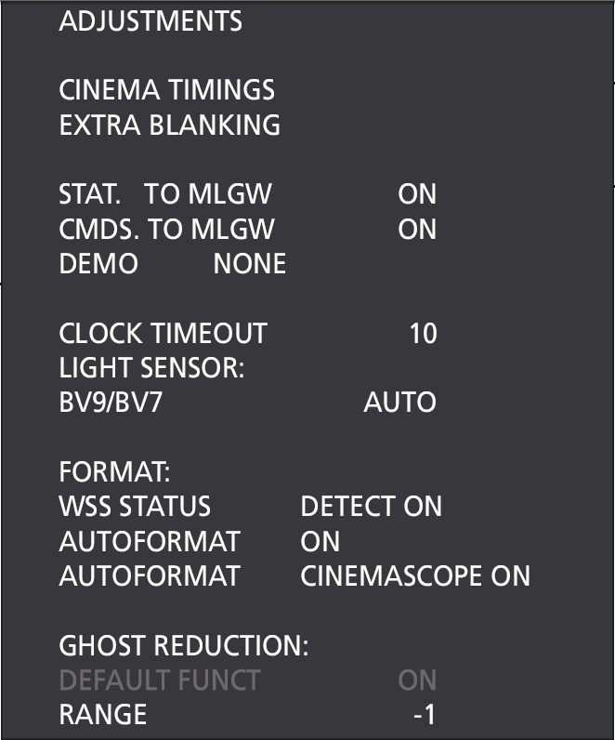
STAT. TO MLGW (Master Link Gate Way) can be ON/OFF
- Shall only be ON if status to a control panels is needed
CMDS. TO MLGW (Master Link Gate Way) can be ON/OFF
- Can be set ON for enabling reroute of all LIGHT and CONTROL commands from remote to MLGW.
- It is recommended only to have one product in a room with this setting to ON
- Three or more products in a room can cause fail on ML
Both settings are default OFF

If TV Hardware is prepared for the POWER SAVING option then
bring up the TV SETUP menu and select OPTIONS.
Select STANDBY SETTINGS if available.
If STANDBY SETTINGS is not available at this menu level, then TV does not have this option.
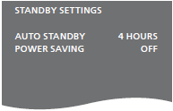
POWER SAVING can be ON/OFF. Settings is default ON
- Set POWER SAVING to OFF to ensure TV always can receive commands from MasterLink, MLGW and iPhone.

